__________________________________________________________________________________________________
Unit 1: Thinking Geographically

Sun-Powered Airplane Completes Historic Trip Around The World
July 26, 20167:56 AM ET
BILL CHAPPELL
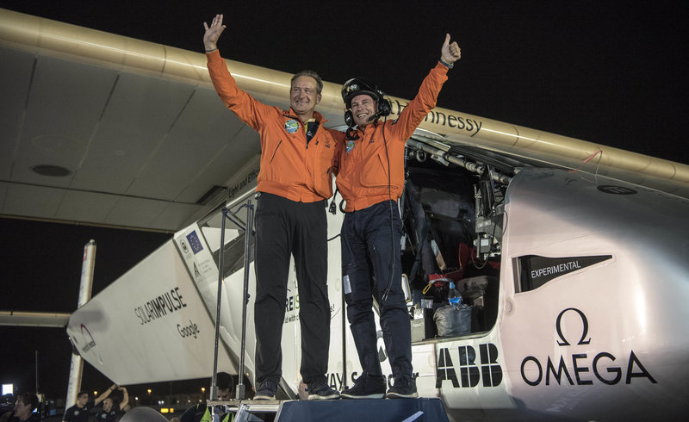
After Solar Impulse's successful landing in Abu Dhabi, the capital of the United Arab Emirates, with Bertrand Piccard at the controls, he posed with fellow pilot Andre Borschberg. The two alternated on 23 days' worth of flights without using any fuel.
Christophe Chammartin/REZO/IMPULSE
The trip had mechanical setbacks, and the plane's average speed would be legal on many American streets. But when the Solar Impulse aircraft touched down in Abu Dhabi in the early morning darkness Tuesday, it successfully completed a round-the-world voyage using only solar power.
Swiss pilots Bertrand Piccard and André Borschberg took turns flying the single-seat aircraft that began its trip on March 9 of 2015, flying more than 26,700 miles in a total of 17 stages (23 days) as they soared under the sun's power and then glided through the night.
When the Solar Impulse 2 airplane arrived in Spain from New York last month, it was greeted by the Spanish Eagle Patrol.
Solar Impulse
"This is not only a first in the history of aviation; it's before all a first in the history of energy," Piccard said. "I'm sure that within 10 years we'll see electric airplanes transporting 50 passengers on short to medium haul flights."
"But it's not enough," Piccard added, saying that the solar technology that powered his plane can also be used on the ground to cut emissions in half.
The journey earned numerous records, including the trans-Pacific leg flown by Borschberg that took five days and nights, setting a mark for the longest solo flight in any airplane, according to the team behind Solar Impulse.
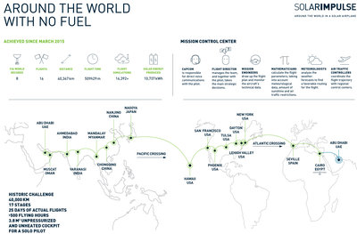
Enlarge this image
The path of Solar Impulse is shown in this graphic released by organizers of the sun-powered flight project.
Solar Impulse
Here are the stats on the flight's final leg from Cairo to Abu Dhabi:
- Pilot: Bertrand Piccard
- Flight time: 48 hours, 37 minutes
- Maximum altitude: 28,000 feet (8,534 m)
- Average speed: 34.5 mph (55.40 km/h)
- Flight distance covered: 2,694 km (1,674 miles)
As Merrit reported for the Two-Way, when Solar Impulse embarked on its final leg, organizers called it one of the most complex they'd undertaken, citing high temperatures on the ground, strong thermal currents and no-fly zones.
The plane and its crew also coped with challenging trans-oceanic flights, crossing the Pacific in two stages (including a stop for repairs in Hawaii) and crossing the Atlantic in 71 hours.

Citation:
Chappell, B. (2016, July 26). Sun-Powered Airplane Completes Historic Trip Around The World. Retrieved May 09, 2017, from http://www.npr.org/sections/thetwo-way/2016/07/26/487458905/sun-powered-airplane-completes-historic-trip-around-the-world
__________________________________________________________________________________________________
Unit 2/3: Population and Migration, Culture
Resource #1:
The World Factbook: UNITED ARAB EMIRATES. (2017, May 30). Retrieved May 09, 2017, from https://www.cia.gov/library/publications/the-world-factbook/geos/ae.html
Resource #2:
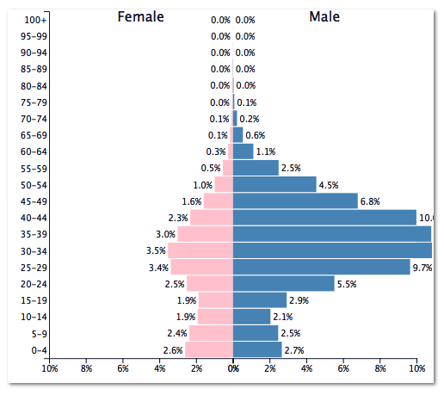
Source: https://www.populationpyramid.net/united-arab-emirates/2016/
Resource #3:
UAE: A Move to Protect Migrant Workers
‘Contract Fraud’ Measure Can Deter Forced Labor
(Beirut) – A United Arab Emirates ministerial decree that takes effect in January 2016 could help protect low-paid migrant workers from a practice that can contribute to forced labor. It is the first measure of its kind in Gulf Cooperation Council countries, but it lacks details on implementation and enforcement and does not apply to domestic workers.

Migrant workers in the Gulf Cooperation Council countries of Bahrain, Kuwait, Oman, Qatar, Saudi Arabia, and the United Arab Emirates have told researchers and journalists that when they arrive in these countries, they are forced to sign contracts that pay less than promised in contracts they signed before they left their own countries to take the jobs. This contract substitution can make workers vulnerable to forced labor, especially if workers have taken on debts to pay recruitment fees. The new law passed on September 27, 2015.

“A major complaint of migrant workers in the UAE is usually that they’re not being paid what they were promised, so UAE authorities deserve credit if this law ends contract substitution,” said Joe Stork, deputy Middle East director. “Its success will depend on whether workers will have access to complaint mechanisms when employers don’t abide by the new regulations.”
A major complaint of migrant workers in the UAE is usually that they’re not being paid what they were promised, so UAE authorities deserve credit if this law ends contract substitution. Its success will depend on whether workers will have access to complaint mechanisms when employers don’t abide by the new regulations
Joe Stork
Deputy Middle East Director

Article 1 of Ministerial Decree 764 of 2015 states that, “tentative approval to admit a foreign worker for the purpose of employment in the UAE cannot be granted until an employment offer that conforms with the Standard Employment Contract is presented to and duly signed by the worker.”
Employers must use Labor Ministry standard employment contracts, and workers can only be registered for employment after signing such a contract, which “captures exactly the terms of the employment offer.” A standard employment contract in the UAE contains information on pay, date and duration of the contract, and the nature of the work to be performed.

Implementation and enforcement will be central to the new law’s effectiveness, Human Rights Watch said. Workers should be able to retain copies of the standard employment contract they sign in their countries of origin, contracts should be written in a language they understand, and they should be able to access a grievance mechanism in the UAE that can resolve complaints quickly and penalize offenders.

Labor Ministry decrees number 765 and 766, outlining the rules for terminating employment and granting work permits to new employees, will also take effect in January. These rules will partly govern how the kafala visa-sponsorship system operates in the UAE. Kafala systems, which operate across GCC countries, tie foreign workers’ residence and work permits to their employers and restrict their ability to change employers.

Decree 765 states that workers on a “renewed term contract” can unilaterally terminate their employment, but only if they effectively buy out the contract. If the parties have not agreed on the sum, the decree sets it at three months’ wages. Workers on their first contract with their UAE employer do not appear to benefit from this clause. The decree also states that a work relationship shall be de facto terminated if an employer “has failed to meet contractual or legal obligations to the worker (as in, but not limited to, the non-payment of wages for a period exceeding 60 days);” a business has been inactive for two months; a labor court finds in favor of a worker in a case relating to arbitrary or early termination; or the unlawful denial of benefits, including end-of-service benefits.

This provision of decree 765 is similar to the terms of Ministerial Decision No. 1186 from 2010, which allows a worker to transfer employers when the work contract expires, without employer approval. It also allows workers to change their employer before a contract expires, whether an initial or renewed contract, without penalty or their employer’s permission if their employer violates “legal or consensual” obligations; if the employer has “not exercised activity for more than two months,” as verified by a report from the Labor Ministry’s inspections department; if a court rules in favor of the employee in a case referred by the Labor Ministry; or if the employer terminates or neglects to renew the worker’s contract.

The ministerial decision does not provide a comprehensive list of the “legal or consensual” obligations that give an employee the right to change employer, but it provides one example – “non-payment of wages for sixty days.” Prior to that law change, workers had no legal authority to change employers before the end of their contracts, but the UAE has not released any figures on how many workers have used the new law to change employers.

A major problem is that 2010 ministerial decree and the new Ministry of Labor decrees do not apply to domestic workers, as they are explicitly excluded from the UAE labor law.

“These changes are another step in the right direction, but domestic workers should not be left behind,” Stork said. “Many domestic workers face forced labor and other extreme abuse, and the UAE should give them the same rights and protections as other workers.”
Citation:
UAE: A Move to Protect Migrant Workers. (2015, November 01). Retrieved May 09, 2017, from https://www.hrw.org/news/2015/11/01/uae-move-protect-migrant-workers
__________________________________________________________________________________________________
Unit 4: Political Geography
UAE Names Minister Of Happiness
February 11, 201610:02 PM ET
MAQUITA PETERS
This undated image released by the Emirates News Agency, WAM, shows Ohood Al Roumi, the newly appointed and first-ever minister of state for happiness of the United Arab Emirates.
"It might seem crazy what I'm about to say,
Sunshine she's here, you can take a break . . .
Clap along if you feel like a room without a roof,
Because I'm happy"
These lyrics from Pharrell's "Happy," 2014's best-selling song in the United States, could set the theme for the United Arab Emirates, where the prime minister has appointed a "minister of happiness."
The renown poet and head of the world's seventh richest country has seen enough dollar signs to know that money does not buy happiness and so he has appointed Ohood Al Roumi to cheer up his people.
Al Roumi, former head of economic policy for the UAE emirate of Dubai, is the current director general of the prime minister's office. She'll keep doing that job while doubling as "minister of state for happiness."
Al Roumi will "align and drive government policy to create social good and satisfaction," Sheikh Mohammed said. "Happiness in the UAE is not just a hope, there will [be] plans, projects, programmes and indicators."
The move, which Sheikh Mohammed bin Rashid al-Maktoum announced Wednesday via Twitter to his 5.58 million followers, comes as part of the biggest cabinet shakeup in the country's 44-year history and during the World Government Summit taking place in Dubai.
"Happy" is not the only tune Sheikh Mohammed is singing. He's also created a minister of tolerance and refocused the Ministry of Cabinet Affairs as Ministry of Cabinet Affairs and The Future.
"It is the beginning of a new journey of achievement and giving to the people, and we ask God to help us serve and take care of them," Sheikh Mohammed posted in Arabic.
Sheikh Mohammed says that he wants to make the UAE "one of the best countries in the world" within five years, and he's created a poem "Happy Nation" to match that vision:
"Our people are happy and in their prime,

Since the days of Zayed till the end of time.
Blessed with honor and dignity they thrive,
Admonished by none, they lead a joyous revive.
While some struggle with obstacles and strain,
Our people are sheltered from agony and pain.
Their children wrapped in peace, they do not fear,
For their wishes and desires, they need not shed a tear.
They live in justice, their dreams fulfilled,
Not chasing illusions, their visions instilled."
According to the New York Times, however, not everyone is smiling at this new mandate.
"The Ministry of Happiness sounds sort of Orwellian and sinister given that this is a surveillance state, but it is in line with their quite high self-regard," said Nicholas McGeehan, a researcher at Human Rights Watch. "You can be happy as long as you keep your mouth shut," Mr. McGeehan said. "That is the sort of social contract that is in place there."
Multiple media outlets have described the UAE's appointment of the minister of happiness as reminiscent of Bhutan's move in 1972 in creating a Gross National Happiness Index, valuing and promoting happiness as much as its economic success.
The Times reported the UAE ranked No. 20 on the 2015 World Happiness Report, above Britain and below Belgium, with Switzerland No. 1, and the United States No. 15. It would appear the UAE will be singing, clapping and dancing its way like Pharrell to that No. 1 spot.
Citation:
Peters, M. (2016, February 11). UAE Names Minister Of Happiness. Retrieved May 09, 2017, from http://www.npr.org/sections/thetwo-way/2016/02/11/466441262/uae-names-minister-of-happiness
__________________________________________________________________________________________________
Unit 5: Agriculture

__________________________________________________________________________________________________
Unit 6: Industry and Development
Why Dubai is Growing So Fast—And May Eventually Slow Down
SEPTEMBER 10, 2014
by Dan Stone
Anyone who’s ever seen a photo of Dubai knows how quickly the city has turned desert into metropolis. And anyone who’s ever stepped foot in the city knows that photos don’t do justice to the massive scale of the city’s ambition. Ski slopes sit adjacent to man-made islands, not far from aquariums encased in enormous shopping malls, and hundreds of high-rise condos, many still awaiting residents.
Now, finding a Dubai hotel with fewer than five stars is harder than it was to find Dubai on a map 30 years ago. That was before the city state—de facto culture capital of the United Arab Emirates—found oil, leveraged its oil, then realized the oil wouldn’t be sustainable, so it diversified its economy into tourism and real estate.
But the cornerstone of Dubai’s economy isn’t oil, it’s logistics: getting people and materials into a city that not long ago was just overheated expanse of desert.
Welcome to Al Maktoum International Airport, Dubai’s second busiest passenger airport (and highly unhappy about being in second place). The current busiest is Dubai International, home of Emirates, one of the world’s biggest airlines. Dubai International will be expanded too, but Al Maktoum, which is part of an even bigger complex called Dubai World Central, will ultimately be bigger and busier.
Last week, Dubai’s ruler Mohammed bin Rashid Al Maktoum endorsed a $32 billion influx of money to start building the world’s largest travel hub. Under a ambitious plan to grow Al Maktoum, the airport aspires to accommodate 200 million people—far bigger than the current busiest airport in Atlanta (94 million passengers a year), as well as Beijing (83 million), and London (72 million). Dubai’s project will take six to eight years and, when finished, is likely to be the go-to crosswords for international travelers, goods, and of course, money. Just watch the promotional video the airport authority already made.
What allows Dubai to grow this fast? The trite answer is oil, but it’s not entirely true. Its leaders wisely knew in the early 2000s that oil wouldn’t last more than a few decades, so it invested in trying to build a more stable economy that would bring in money the old fashioned way, by building a city attractive enough to entice people to come, stay, and cash their paychecks. Dubai’s prowess is impressive, yet not entirely to its own credit. Heightened security on travel to the west after Sept. 11, 2001, in combination with big, populous countries like India and China building new classes of consumers eager to spend their new money, has created a perfect storm for Dubai to cash in.
The bigger question, and the only one that matters, is whether it can keep the party going. Visiting Dubai, I remember being struck by the emptiness. Enormous buildings shoot up practically overnight, then sit vacant. Cafes with fine food from all over the world seemed to have more chefs than patrons. Ample supply, sluggish demand.
For now, there just aren’t that many Emiratis. Ninety percent of Dubai’s population is comprised of guest workers from places like India, Bangladesh, and Vietnam—a strange imbalance explored at length in the January 2014 issue of our fine magazine. On top of that, there simply aren’t enough tourists yet.
The wisdom of Dubai’s ruler Mohammed bin Rashid Al Maktoum is that building a bigger airport will maintain, and, he hopes, increase, the inflow of foreign cash. It’s hard to imagine Dubai becoming even bigger, even flashier, accommodating even more people. Ultimately, no matter how badly he wants it, Sheik Mohammed won’t be the one who decides Dubai’s fate. It’ll be the newly-middle class Bangladeshi who decides to vacation in Dubai, or buy goods shipped through the UAE, or invest in a company with business dealings in the Emirates. Millions of people will soon be looking for places to bring their increasing income. Dubai’s big bet is whether it’ll be the most attractive place to spend it.

Citation:
Stone, D. (2014, September 10). Why Dubai is Growing So Fast—And May Eventually Slow Down. National Geographic. Retrieved May 10, 2017, from http://onward.nationalgeographic.com/2014/09/10/why-dubai-is-growing-so-fast-and-may-eventually-slow-down/

