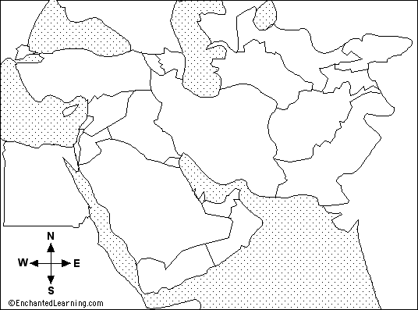

Label on map:
Egypt Oman
Turkey Yemen
Syria Red Sea
Cyprus Persian Gulf
Lebanon Gulf of Oman
Israel Caspian Sea
Iraq Mediterranean Sea
Iran Black Sea
Saudi Arabia Arabian Sea
Qatar Gulf of Aden
Beirut Strait of Hormuz
Bahrain United Arab Emirates
Kuwait

