MUSIC AND DANCE
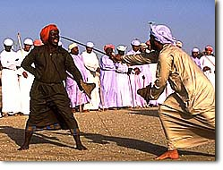
The United Arab Emirates enjoys a strong tradition of music and dance which played a vital role in many aspects of its people's lives. Songs were composed to accompany different tasks, from hauling water at the well, to diving for pearl oysters out in the Gulf. In the latter case a professional song leader was kept on the pearling dhows whose job it was to rally the men to work through music and song. The naha'an, as this person was known, would launch into song and all the sailors would join in as they worked. Each song had a rhythm for a particular task and, like the sea shanties of western sailors, the music became an inspiration for good team work.
In the evenings, around a fire in the desert, men would meet to talk and exchange news. It was also an occasion for storytelling and for reciting poetry. During celebrations singing and dancing also took place and many of the songs and dances, handed down from generation to generation, have survived to the present time. Young girls would dance by swinging their long black hair and swaying their bodies in time to the strong beat of the music. Men would re-enact battles fought or successful hunting expeditions, often symbolically using sticks, swords or rifles.

Go to the following websites and view the videos

https://www.youtube.com/watch?v=wHN7RT8Ndzc

https://www.youtube.com/watch?v=_AUmIhUdNGs

