Cultural Convergence vs. Cultural Divergence

Cultural convergence – occurs when different cultures exchange ideas and become more similar.

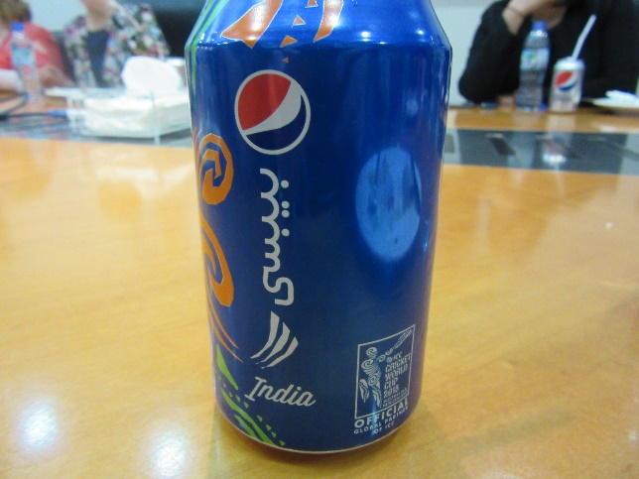

Cultural divergence – occurs when different cultural influences cause an area to divide into separate parts.

Foldable

- Take a sheet of paper and fold it hot dog style

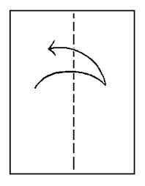

- Make two slits so the flaps open up
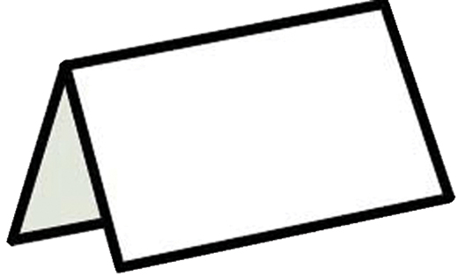

- Label one box cultural divergence and the other cultural convergence

- On the inside write the definition of both terms in your own words and include a picture

Name________________________________

Pictures from the UAE

Image # | What do you see? | Is this picture showing cultural convergence or cultural divergence? Why

