Men’s Wear
Men wear the dishdash also referred to as dish-dasha or even gandoora, gandurah or even tawb or taub (long white robe) and the headscarf (keffiyeh). (Pictured: two emiraties in traditional clothing)
The UAE traditional Keffiyeh is white and is held in place by the agal (for which the pluriel is aghals) which resembles a sort of black heavy duty hosepipe. The keffiyehs worn in the neighbouring countries are not necessarily white and each Bedouin tribe will have its own colours. The younger emiraties prefer to wear red and white keffiyehs like the one worn by the Yasser Arafat and tie it round their head to avoid having to wear the agal. Just like with the women’s abaya, the dishdash and keffiyehs are often made foreign famous French English or Italian couturiers.
To wear the Keffiyeh the Emirati style, all you have to do is fold the headscarf once to make a triangle placing the longer side of the triangle along the forehead leaving the 90˚ corner somewhere towards the top of your back. Then all you have to do is place the aghals on top leaving the black chords dangling in your back.
If you want to wear your keffiyeh without using the aghals, simply make a triangle as described above and use the two small-angled corners to wrap them round your head, starting with the back of the head, and around the forehead to fold it back into the beginning of the loop just behind the ears. Do not use the aghals when wearing the keffiyehs in this style.
All Emiratis aged from 5 or 6 onwards wear this traditional clothing.

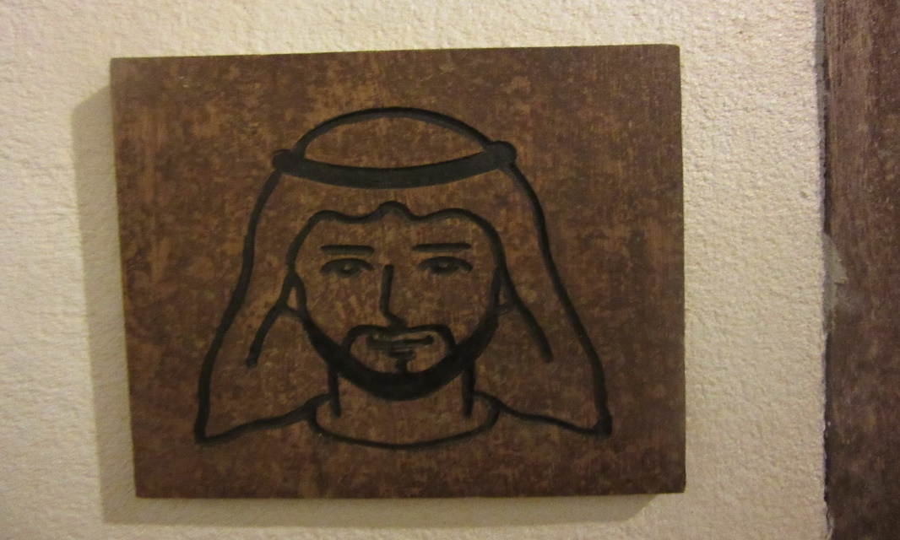

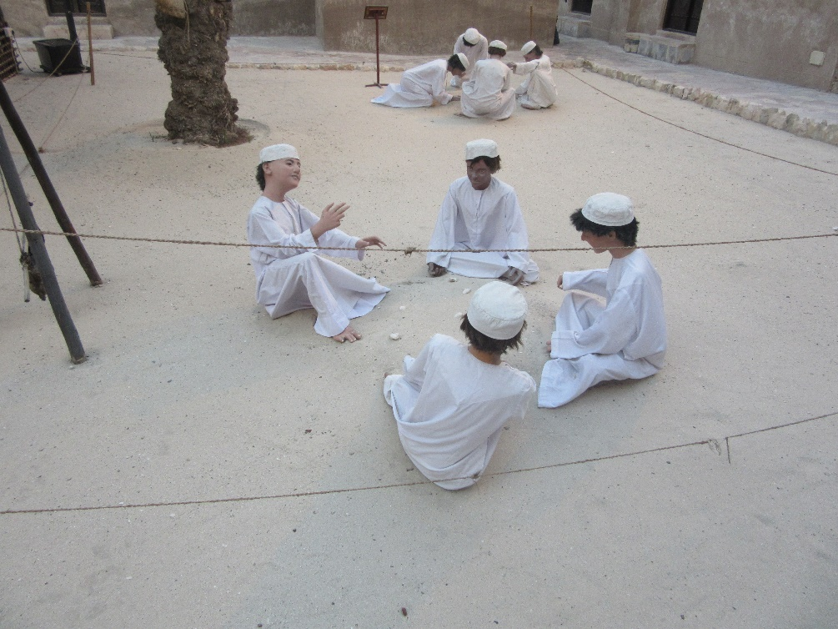

Women's wear
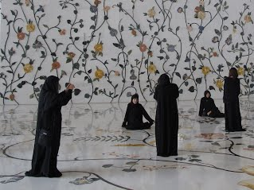
Women wear the abaya, a long black robe with a hijab (the head-scarf which covers the neck and part of the head). Some women may add a niqab which cover the mouth and nose and only leaves the eyes exposed. Alternatively, some women pull their hijab aver their faces so no part of their face is visible. (On the picture to the right women wear the abaya and the hijab in the local Emirati fashion).
The abaya is traditionally completely black but today, you might see some with colorful embroideries around the collar or on the sleeves. Furthermore, these days, the younger generations of Emiratis like to wear fitted abayas when these were originally designed to hide or prevent from revealing any physical shape.
All women are all dressed in black which is obviously not the best choice of color considering the extreme temperatures experienced in this part of the world in the summer. This also explains the extravagant air conditioning in public areas.
On the other hand, they are dressed in an extremely fashionable manner below the abaya which they remove when solely in the presence of women or when at home. Similarly, their love for fashion is reflected by the fact that Emirati women buy abaya made by some of the greatest couturiers such as Dior, Pierre Cardin, Channel etc….

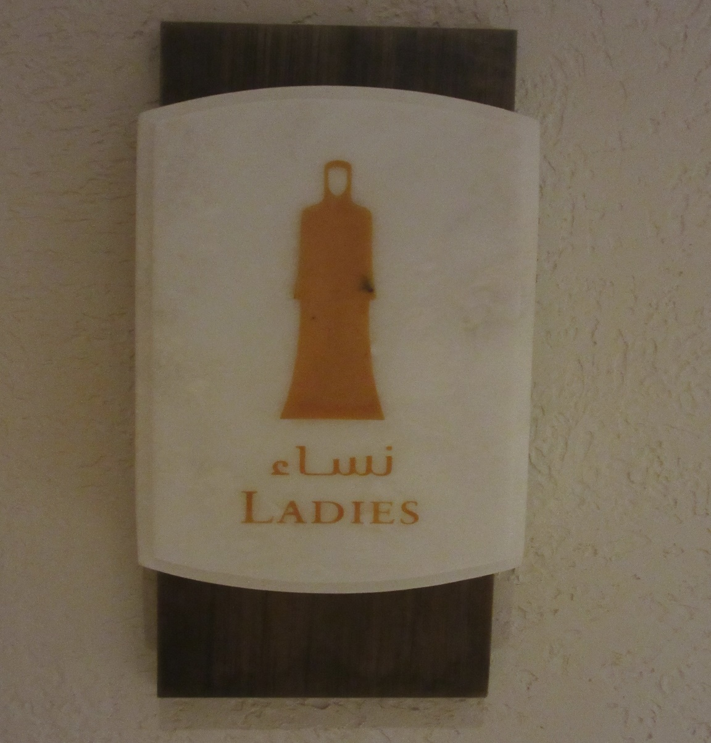

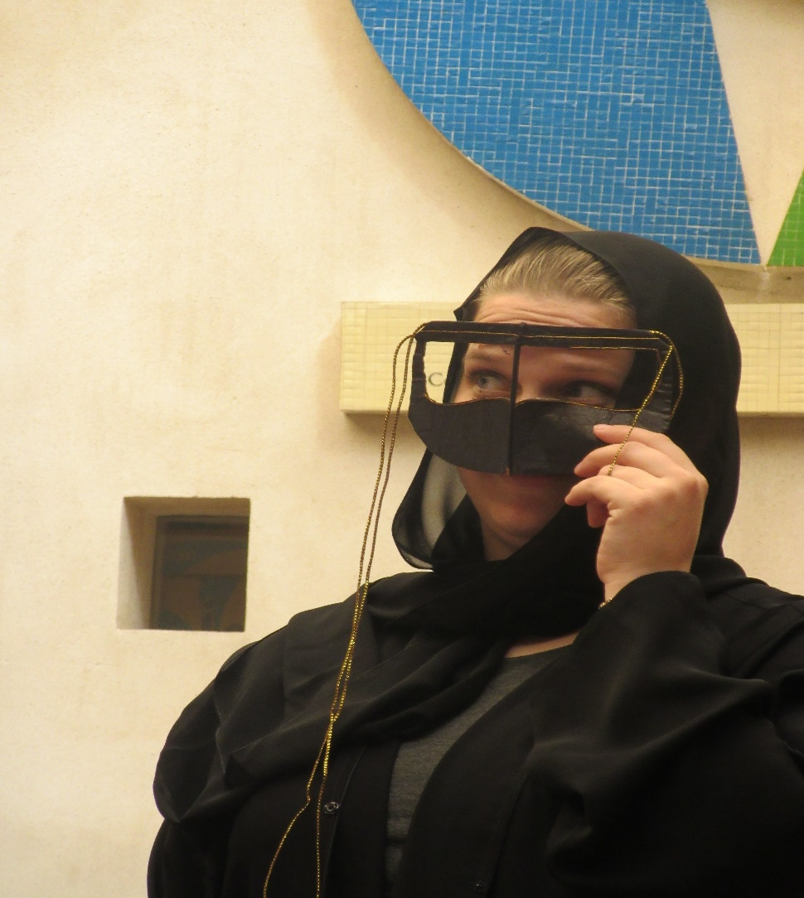

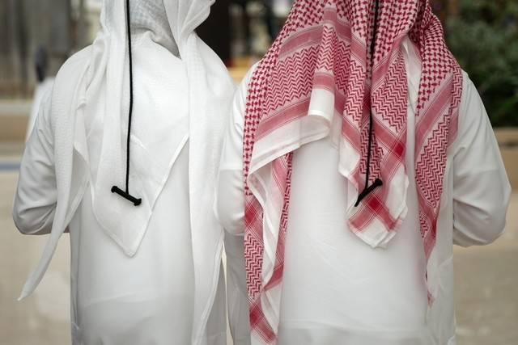
The National dress is a source of pride for Emiratis. Silvia Razgova / The National

National dress is important, but doesn’t define who we are
Khalid Al Ameri
April 6, 2014 Updated: April 7, 2014 08:48 AM

Earlier this year, the FNC heard calls for a strategy to be put in place to protect our national dress, possibly through the passage of a law or the implementation of certain codes.
As The National has reported, many young people believe the kandura and abaya are still very much in fashion and a source of pride.
I love it when I wear our national dress, although I have certain reservations about its place in certain work environments, and nothing makes me prouder than being able to represent my country day in and day out.
However, I question whether what I am wearing should be at the forefront of my national identity – as opposed to who I am, what I stand for and the things I am doing to give back to my country.
In recent interviews with The National, several Emiratis discussed reasons why they were proud to be wearing national attire, and although it is heartwarming to read about those feelings of pride, I feel that it may be somewhat misplaced.
The first comment that got me thinking was: “When people see you in the kandura, they have more respect for you.” When it comes to a country as diverse as the UAE, managing respect across nationalities, ethnicities and religions can be a tough task. It simply boils down to being open and kind to each other regardless of personal beliefs; this is what creates a deeply rooted culture of camaraderie within our country that will be passed down from generation to generation.
However, if we were to base our respect for each other on something as materialistic as what we are wearing, then the feelings of togetherness and bonding between different people is merely an act.
Young Emiratis should not feel that respect is a birthright, or something that can be managed based on whether they decided to put on a kandura or abaya today. Respect must be earned through actions, attitudes and interactions with other people.
This is important because if there is a culture where someone who dresses as an Emirati gets more respect, does that mean that someone who dresses in the attire of another country should get less respect?
A second sentiment among the people who were interviewed was that they felt that because they were Emiratis, they had to wear it. Although I believe national dress is important to maintaining culture and representing our nation, it is not something that has to be worn for those things to be carried out. Emiratis have done amazing things on all fronts – social, economic and entrepreneurial – which they would have done regardless of what they were wearing. This is because their source of patriotism and energy to make our nation better is so deeply rooted within who they are that what they wear doesn’t even matter.
A final thought relates to national dress being required for Emiratis to stand out because they are a minority within their own country. For the most part I agree with that reason, however I would again argue that how we act, how we carry ourselves and how we engage with the various communities across the UAE can make us stand out so much more.
A remarkable example of this is ThinkUp GCC, a group of Emiratis who start, and take part in, a variety of initiatives from representing UAE talent and managing Ramadan food drives to raising awareness for non-profit organisations around the country.
Nobody thinks about what they are wearing when they engage in acts that give back to the citizens and residents of the UAE; they are just proud to take time out of their day to help others and expect nothing in return. That is what makes them stand out far more than any item of clothing could.
The UAE continues to grow every day, and as it becomes more a part of the global community I would love to see us hold on to our culture.
However, that culture should be one that is built upon the characteristics that our forefathers brought to the world, such as our beautiful poetry, our heartwarming hospitality and our unquestionable loyalty to each other and to the betterment of our country.
That is how respect is earned, grown and passed down through generations, regardless of what you are wearing.
Khalid Al Ameri is an Emirati social commentator

Questions on the article

- What do many young people in the UAE believe about the kanudra and the abaya?

- What is this article about?

- How should respect be earned?

Female Dress in the UAE

Male Dress in the UAE

