U.A.E. and U.S. Diplomacy
Melissa Taylor
AP World History
Timber Creek High School, Keller ISD
Melissa.Taylor@kellerisd.net

Objective
Students will be able to identify major components of diplomatic relations between the United States and the United Arab Emirates.

Standards met
TEKS 11. The student understands the emerging political, economic, and social issues of the United States from the 1990s into the 21st century. The student is expected to: (A) describe U.S. involvement in world affairs; TEKS (25) Culture. The student understands how the development of ideas has influenced institutions and societies. The student is expected to: (D) explain how Islam influences law and government in the Muslim world.

Lesson Sequence
Engagement
Part I:
Objective: Students will be able to demonstrate the importance of collaboration and will discuss aspects of international diplomacy.
- Start with a team-building exercise that forces students to collaborate and work together to problem solve.
- I personally like “Zoom”, which is an activity where each person in the group is given one picture out of a sequence that will create a unified story; they cannot show their picture to any of the others in the group. Through communication and patience, participants must re-create the story line. More details can be found at this website: http://www.wilderdom.com/games/descriptions/Zoom.html.
- Another good team-building exercise is the “survival scenario”; students really enjoy these and requires a lot of problem solving and analysis. More information can be found here: http://www.wilderdom.com/games/descriptions/SurvivalScenarios.html.
- Debrief the activity with a discussion about collaboration and problem solving. The following questions can be used to generate the discussion:
- What did you find difficult about the activity? What was easy?
- What kind of communication was used in attempting to solve the problem? What kind of communication methods would have worked better? What prevented these strategies from taking place?
- What kind of leadership was used to solve the problem? Why? Looking back, do you think a better type of leadership would’ve been better?
- What do you think went well? What do you think you would change in the future?
- What real life activities are similar to this activity?
At this point, guide the class discussion into a more specific look at international diplomacy. Some of these questions from U.S. Department of State can be used to help facilitate your discussion:
- Do the terms “foreign policy” and “diplomacy” mean the same thing?
- What do you know about the U.S. Department of State, also known as the State Department?
- Why do you think that the United States maintains diplomatic relations with foreign countries?
- Why does the United States offer foreign assistance to countries overseas?
- What role does diplomacy play in the making of a successful world leader?
- How does diplomacy help promote human rights in other countries?
- How does diplomacy help promote trade and investment?
- What are the benefits of international cooperation in scientific research? What are the obstacles?
- How does diplomacy work to prevent terrorism?
- How can you find out more about your country’s role in foreign policy initiatives?

Part II
Introduce students to the United Arab Emirates. Begin by showing them this 20 minute video clip that shows a brief look at all seven of the emirates: https://youtu.be/F585Gtp2c0E
Once you finish the video, ask students what their opinion is of the U.A.E. After seeing the video, were they surprised in any way? What do you think of U.S.-U.A.E. international relations?

Exploration
Objective: Students will explore U.S. and U.A.E. international relations.
Students will choose a topic that interests them and will explore U.S. and U.A.E. relations in regards to their given topic. Some topics students can choose from are listed below or discuss with the teacher about another topic they would like to explore:
- Education
- Women’s Rights
- Human Rights
- Economic Partnership
- Sustainable Energy
- Confronting terrorism and extremism
- Environmental Support

  - A good starting point for research would be the U.A.E. embassy’s website:
(http://www.uae-embassy.org/).

  - If students chose to explore “Confronting Terrorism and Extremism,” a good website to explore is Hedayah’s, an international institution for training, dialogue, collaboration, and research to counter violent extremism (http://www.hedayah.ae/).

  - If students chose to explore “Sustainable Energy,” Masdar institute is a fascinating place and can offer students a great place to begin their research: http://www.masdar.ae/

  - The teacher may want to encourage students to reach out to members of the U.A.E./U.S. embassy to deepen their knowledge and perspective of their topic. Therefore, the teacher may want to contact the following people on behalf of the students or set up a Skype classroom interview.

    - Dr. Alsaghira Al Ahbabi, Second Secretary, Think Tanks-Political Section: salahbabi@uaeembassy-usa.org
    - Dima Alfaham, Chief of Staff: dalfaham@uaeembassy-usa.org
    - Tara Chandra, UAE Embassy Advisor, The Harbour Group: tara.chandra@harbourgrp.com

Explanation
Objective: Students will create an infographic (a visual image, such as a chart or diagram, used to represent information or data) depicting U.S. and U.A.E. relations.
The following are some examples of infographics:
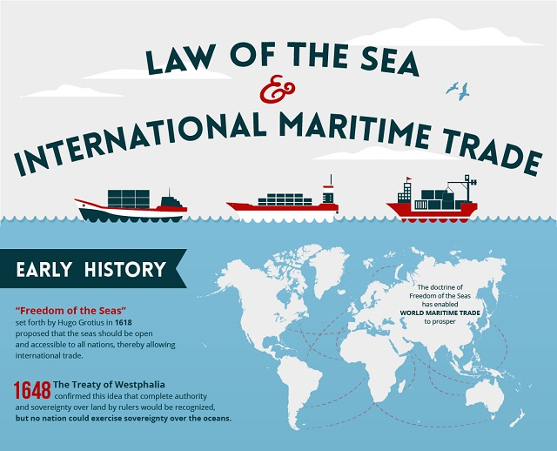

Source: http://www.maritimeexecutive.com/media/images/article/content/NU_MDY_Maritime1.jpg

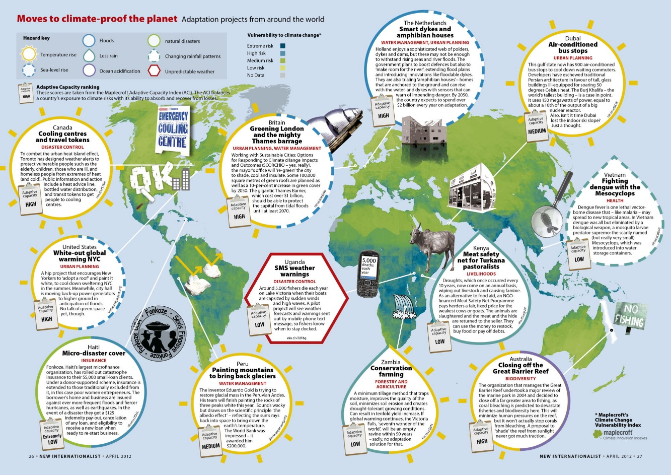

Source: http://newint.org/features/2012/05/14/451-26-infographic-72ppi-2000x1414b.jpg

Students can use the following free and user-friendly websites to create their infographic:
- http://www.easel.ly/ (several templates, allows for a variety of easy customization)
- http://piktochart.com/ (nice templates, easy “drag and drop” tool, limited free features)
- http://infogr.am/beta (good for creating data charts, easy, limited free features)
- https://www.thinglink.com/ (able to provide more depth to infographics since you can embed websites and videos)
- https://www.smore.com/ (flyer format infographic, easily insert pictures)
Expand
Objective: Students will explain and evaluate various aspects of U.S. and U.A.E. international diplomacy.
- The teacher should set up their classroom to allow for a discussion to take place once the students have completed their research and their infographics.
- Students will present their infographics to the class and explain how the U.S. and U.A.E. have collaborated on their chosen topic.
- Initiate a discussion for students to evaluate the strong relationship between the two countries. What problems are they currently working to resolve? Do they foresee any problems in the future that both countries will have to work together towards? What are the pressures their relationship faces? The teacher may want to reference back to the team building activity at the beginning of the lesson to see if students can draw any parallels.
Enrichment
For enrichment purposes, the teacher may want to open up the research and infographic portion to include other Middle Eastern countries in addition to the U.A.E. so that students can compare/contrast each country’s’ diplomatic relationship with the U.S. Students could choose such countries as:

- Egypt
- Saudi Arabia
- Iran
- Israel
- Turkey
- Iraq
- Yemen
- Syria
- Jordan
- Palestine
- Lebanon
- Oman
- Kuwait
- Qatar
- Bahrain

