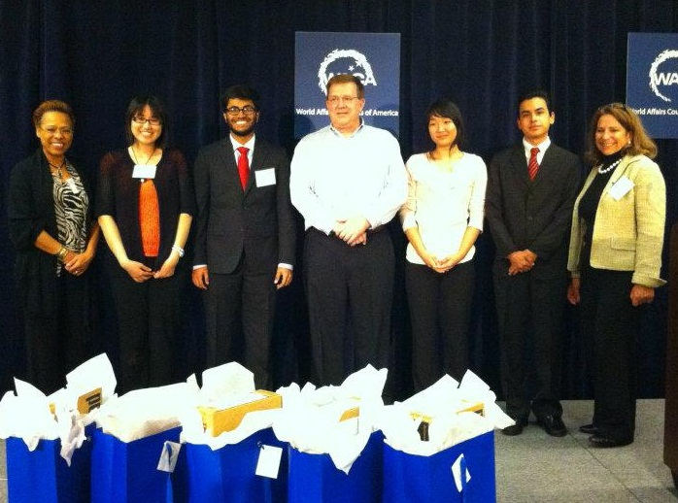

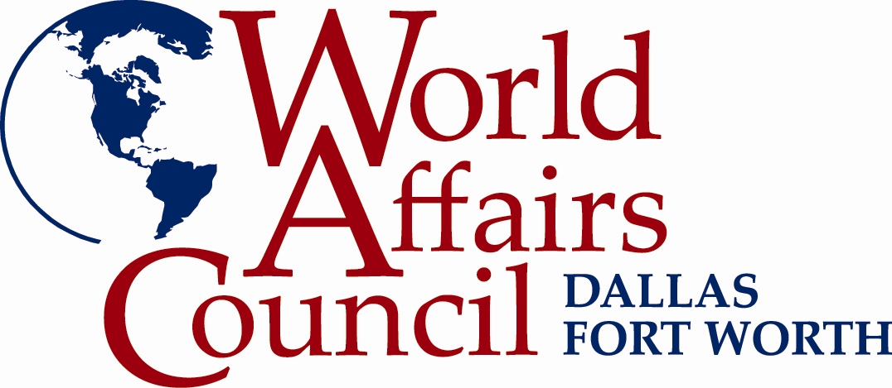

**International Education Program *2011-2012 Highlights***

**The International Education Program (IEP) seeks to educate students and teachers on how international events affect their lives, their communities, and their country.**

In light of the budget cuts affecting schools, the IEP’s work is even more vital to educators as they prepare their students to succeed in our globalized world.

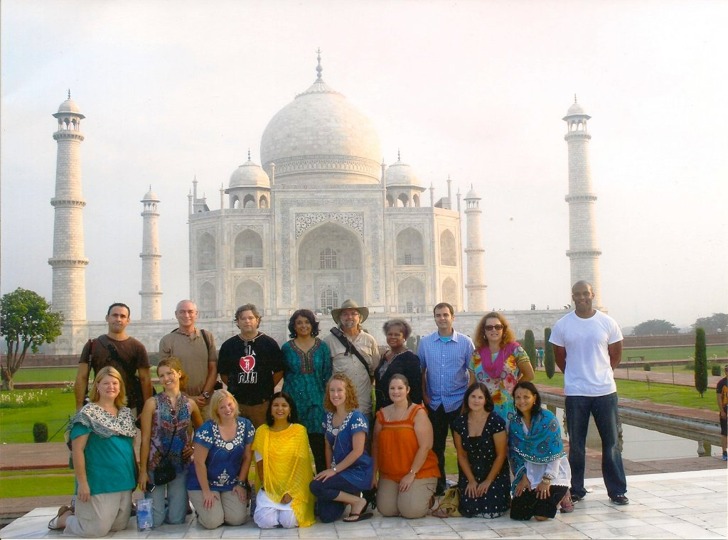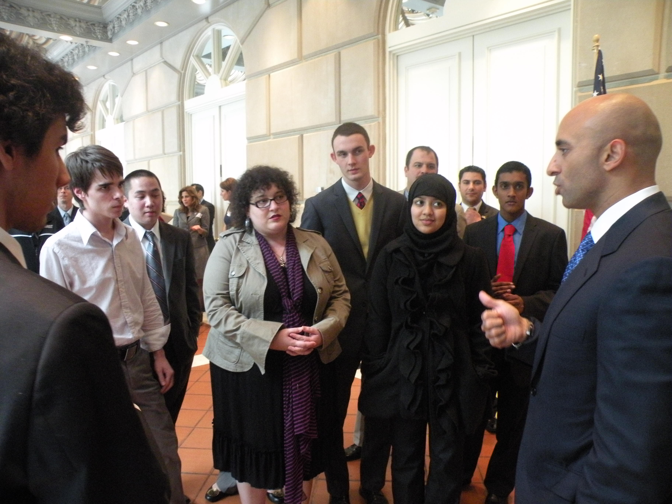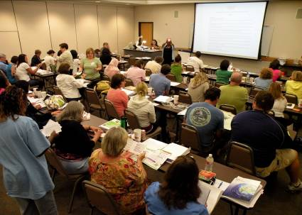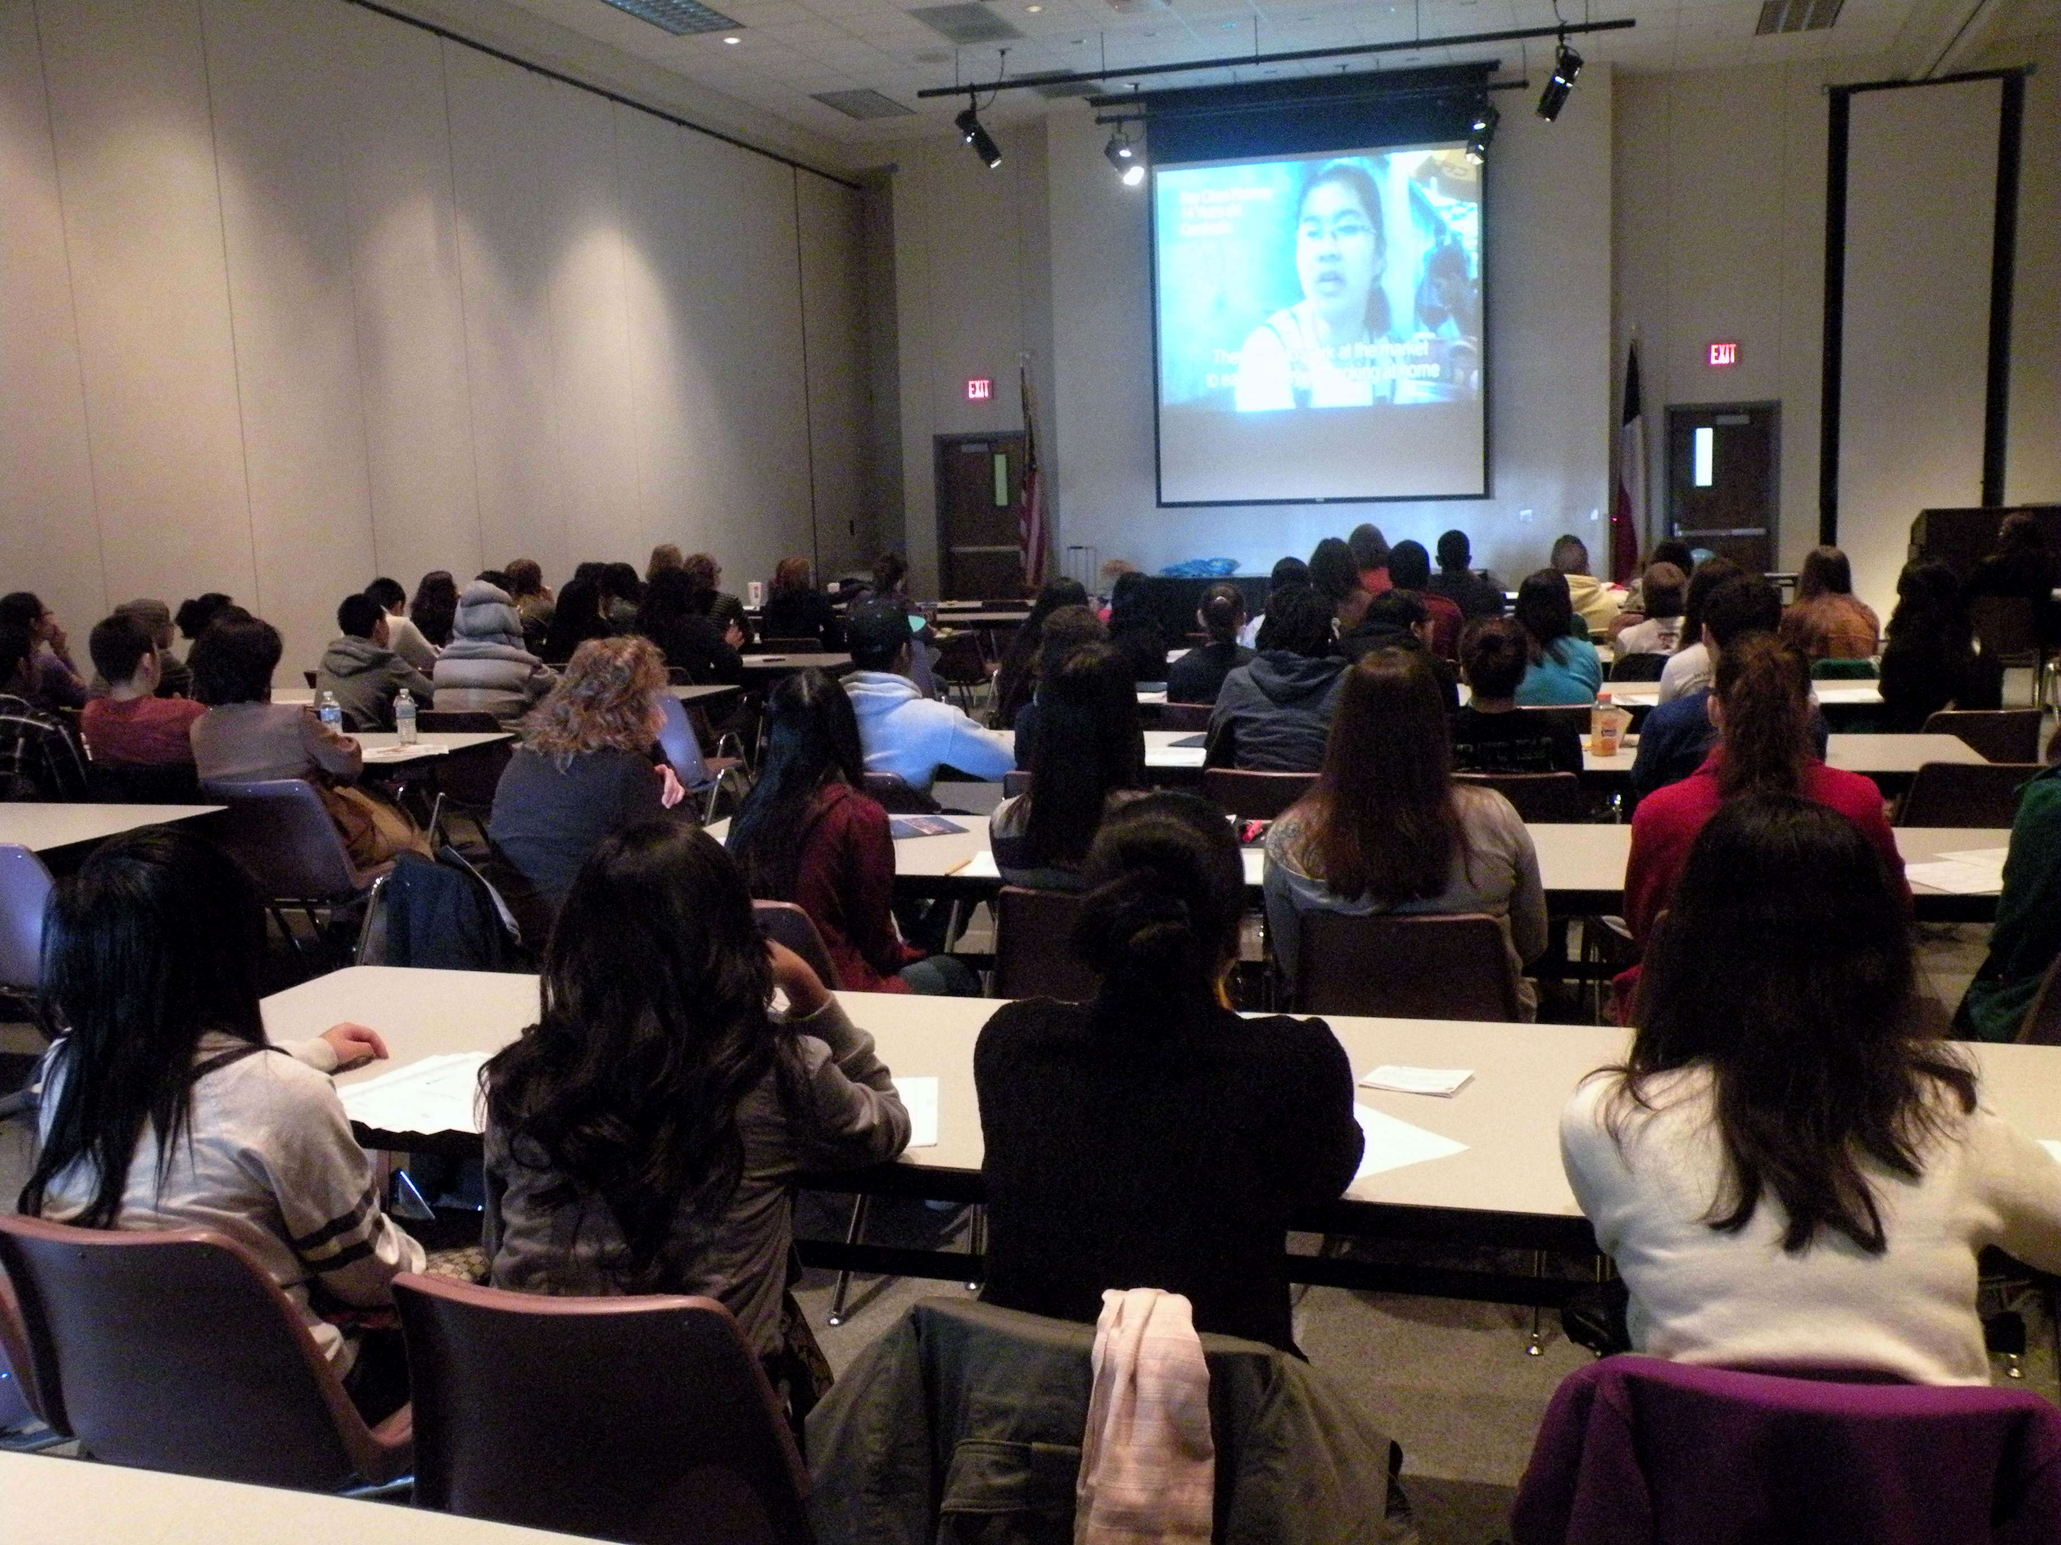

2011 India Fulbright-Hays Study Tour

**Students at Council Events**

Ambassador of U.A.E. to the U.S.

**Educator Workshop**

Global Classroom

**History at the Movies**

Women’s Rights around the World

***Educator forums*** focus on topics that are **central to any discipline** and provide ongoing opportunities for educators to collaborate on curriculum development and reflect on their global competency efforts.

* **Portrait of India and Portrait of Morocco** cultural workshops
* A **World Religions Forums: Islam and Sikhism**, workshops that provides accurate information on world religions to teachers
* **Gifted and Talented** credit for workshops and speaker events
* **Global Classroom**, a two-day workshop utilizing curriculum from National Geographic, MENSA, Population Connection and others
* ***Great Decisions 2011***, a workshop covering topics from the Foreign Policy Association’s annual publication, *Great Decisions*
* Two ***Choices*** workshops covering the U.S. Role in a Changing World and the Middle East through vibrant, interactive multi-media instructional materials and techniques
* The **International Educator of the Year** honoring teacher excellence in fostering global competence in their classroom
* **Mastering the TEKS in World Geography and World History** workshops
* Educator **travel opportunities to India and Morocco** (through third partyprograms)

***Student forums*** enable Dallas/Fort Worth area youth to pose their own questions to world leaders and to **investigate pressing global issues.** Programs provide a powerful lens for emerging leaders to interpret the world.

* **Student attendance at Council events**, where students ask questions and interact with guest speakers such as Stephen Hadley, Minxin Pei and Phillip Coggan
* A variety of **Speakers to Schools** programs with guests such as Gillian Sorensen, William Shawcross, Vijay Vaitheeswaran, Bruce Bueno de Mesquita, Robin Wright, The U.S. Army War College and international visitor delegations
* An **Indian Cultural Day** for 200 students from around DFW
* **History at the Movies** session using film to study women’s rights around the world
* The **International Career Day**, which provided first-hand career advice from global professionals to more than 300 students
* An **Azerbaijan National Essay Competition**, with a DFW student winning a free trip to visit the country in 2012 with nine other students from around the U.S.
* A multitude of community projects such as volunteering at WorldFest in Addison by local **Junior World Affairs Councils**

With partners Richland College and HEB ISD, the IEP was awarded a grant to participate in a **Fulbright-Hays Group Projects Abroad** program and took 17 educators to India in the summer of 2011 to study the United Nations Millennium Development Goals

**Academic WorldQuest 2012**

National First Place Winners –

Plano Senior High School

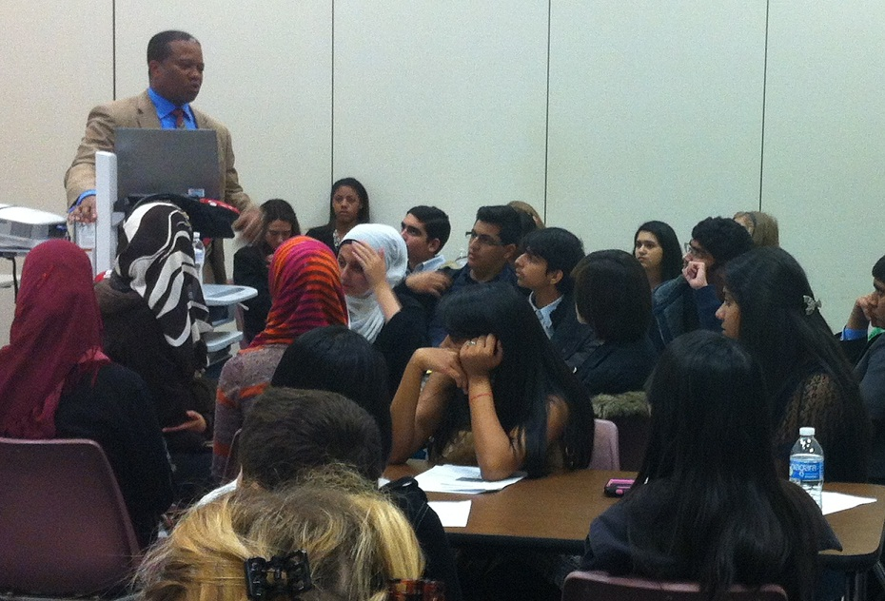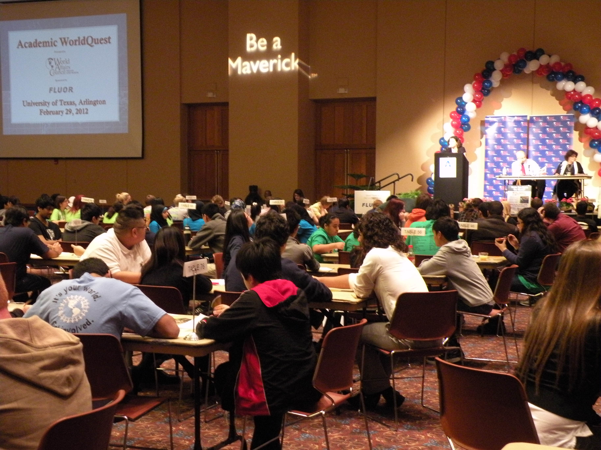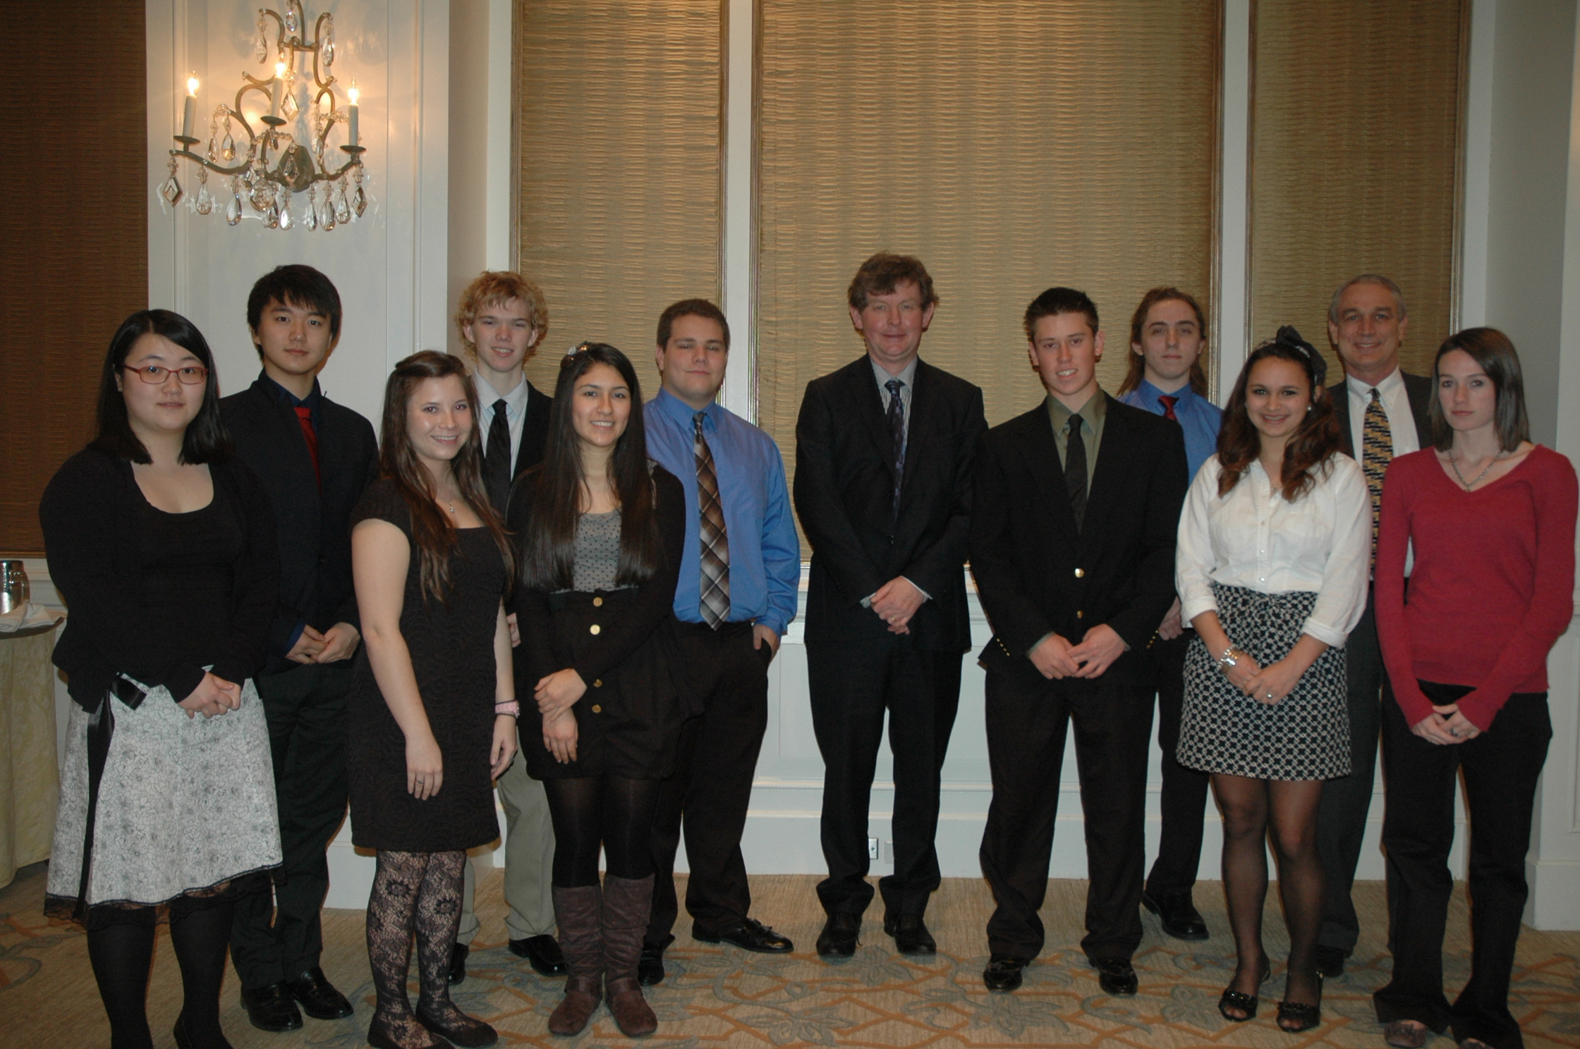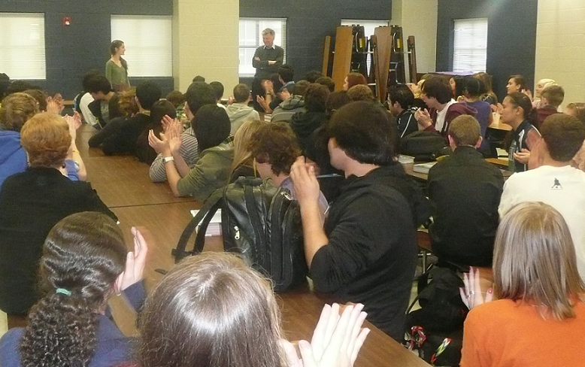22

**Academic WorldQuest**

**For more information about the IEP, contact:**

**Jennifer Bowden, Director of Education**

(214) 965-8415

JBowden@dfwworld.org

www.dfwworld.org

**Educator and Student Membership**

**($25 reduced rate)**

Benefits include: special member rates for programs, invitations to discussion groups, a free subscription to *Foreign Policy* and other reduced subscriptions.

For many students, a Council event is their **first exposure to the world beyond their classroom.** IEP sponsors students and teachers to attend these events and even provides bus scholarships for schools. This year, hundreds of students attended speaker events highlighting topics ranging from Afghanistan to the strategic partnership with the U.A.E. and dozens of topics in between.

**“Thank you for giving my students the opportunity to hear a true “rock star” of foreign affairs.”**

*– Joe Mendenhall, Bell High School*

**Students at Council events**

Every school year, authors, experts, diplomats, and U.S. State Department delegations visit Dallas/Fort Worth schools, interact with students, and speak about global trends and topics.

This year, students from around DFW were able to **meet internationally renowned guests at no cost** at Garland H.S., Harmony Science Academy, Lancaster H.S., Martin H.S., Trinity H.S., Highland Park H.S., St. Marks, Flower Mound H.S., Williams Prep, North Hills, Hockaday, Coppell H.S., LD Bell H.S., UT Tyler, and JROTC in Fort Worth ISD.

**Speakers to Schools**

The International Career Day gave 300 high school students the opportunity to learn about various international career paths and hear **first-hand career advice from global professionals** in human rights, business, journalism, defense, diplomacy and medicine.

**“Most teenagers are unable to relate to situations outside of their world, and this helps a lot.”**

*– Student from Martin High School*

**International Career Day**

**Four hundred high school students** participated in the 2012 Academic WorldQuest sponsored by Fluor, an annual competition that challenges their knowledge of current events and world affairs.

86 teams from 33 DFW schools participated at WorldQuest, which was held at the University of Texas at Arlington. Plano Senior High School won first, Plano West High School won second place, and Flower Mound High School placed third. **Plano Senior High School won the 2012 national competition in Washington D.C. for the second year in a row!**